Ch 6 Test Review Questions
Immune System

- What is the function of physical barriers such as the skin and mucus membranes?
- How do phagocytic white blood cells destroy pathogens?
- What are antigens?
- How do antibodies keep you healthy?
- Explain how vaccinations provide immunity.
- B cells produce ________ that are specific for only one ________.
- How do Memory B cells prevent you from getting ill the second time you are exposed to a disease?
- How do Killer T cells destroy pathogens?
- Why are Helper T cells important to the immune system (they are sometimes called the “Generals”)?
- Describe the following problems of the immune system
  - Allergic reactions-
  - Autoimmune disease-
  - Immunodeficiency disease-
Circulatory (Cardiovascular) System
- How many chambers on in the human heart?
- Describe each of the following blood vessels
  - Arteries-
  - Capillaries-
  - Veins-
- Use arrows to trace the path of blood through the heart. Label the parts indicated. The color chambers and vessels either red (high O₂) of blue (low O₂)
RIGHT LEFT
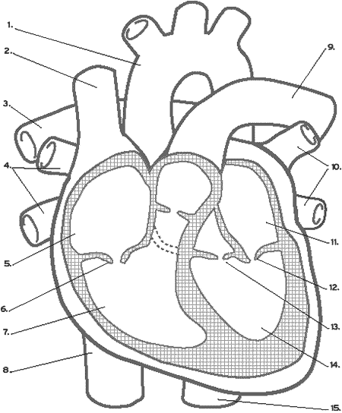

- What substances can be found in plasma?
- What is the major function of red blood cells?
- What is the major function of platelets?
- Describe the following problems of the cardiovascular system
  - Heart Attack-
  - Clogged arteries-
  - Stroke-

