Ch 7 Review Questions
Part A

Organic Molecules
- List the four groups of organic molecules. Where do most organisms get the raw materials to build these organic molecules?
- What three elements do all organic molecules share? Which three elements are sometimes found in organic molecules? What is the way you can remember these?
- Name the type of bond that holds together the organic molecules. Why is this a good type of bond for these molecules?
- Describe the difference between a monomer and a polymer and give one example of each.
- Explain what happens during the chemical process of Dehydration Synthesis. Is water produced or used?
- Explain what happens during the chemical process Hydrolysis. Is water produced or used?
- Name the process illustrated below.
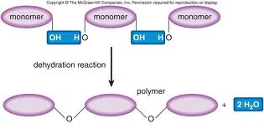
- Name the process illustrated below

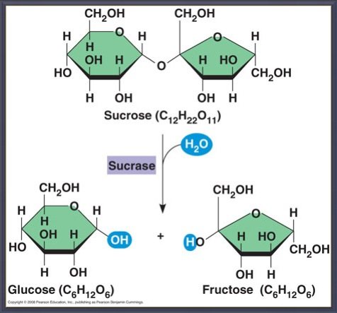
Carbohydrates
- What three elements are found in carbohydrates? In which ratios do they exist?
- Which of the following is the formula for a carbohydrate? (H₂O or CH₃(CH₂)₁₀CO₂H or CO_{2,} or C₆H₁₂O₆) Explain how you know.
- List and describe the two main functions of carbohydrates.
- List the three categories of carbohydrates (based on their size). Which are considered sugars? Which are considered starches?
- Which category of carbohydrate is illustrated below? Explain
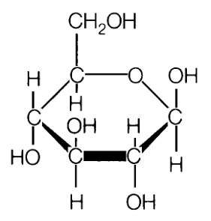

- Which category of carbohydrate is illustrated below? Explain
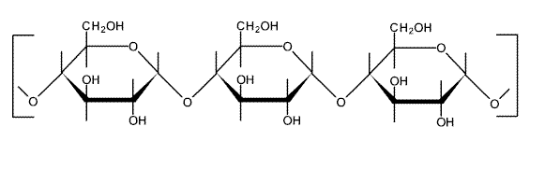
- Which category of carbohydrate is illustrated below? Explain.
