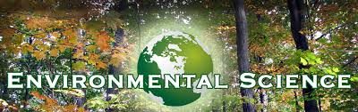

Welcome to the 2014-2015 Year at Middletown High School North
Mrs. Connelly

Extra Help * Block 3 Room 2216

* Every Morning :7:00-7:30
*Tues and Thurs after school
Email connellyk@middletownk12.org

Webpage http://connellysbiocorner.weebly.com

The Academic Year at a Glance
1st Marking Period | 2nd Marking Period | 3rd Marking Period | 4th Marking Period
Unit 1: Introduction to Ecology  Unit 2-Water | Unit 3: Air  Unit 4: Human Populations | Unit 5: Land  Unit 6: Energy | Unit 7: Energy Conservations
Text Book-Holt: Environmental Science (available to read on-line and classroom copies)

Daily Materials
Required | Suggested
Chromebook (once assigned) | Colored Pencils and/or Markers
Ringer Binder (at least ½ inch) and paper | Highlighter Markers (2 or 3 colors)
Pens and Pencils (multiples) | Notecards (3” x 5”)
 | Ear buds or headphones
Grade Calculations
- 20% Quarterly Exams
- 60% Assessments (tests, quizzes)
- 20% Assignments (CW, HW, checks)

